**Assignment - Day 1**

**Chessboard.html**

<html>

<head>

<meta charset="UTF-8">

<title>Chessboard using Pure CSS and HTML</title>

<style type="text/css">

.chessboard {

width: 640px;

height: 640px;

margin: 20px;

border: 25px solid #333;

}

.black {

float: left;

width: 80px;

height: 80px;

background-color: #999;

font-size:50px;

text-align:center;

display: table-cell;

vertical-align:middle;

}

.white {

float: left;

width: 80px;

height: 80px;

background-color: #fff;

font-size:50px;

text-align:center;

display: table-cell;

vertical-align:middle;

}

</style>

</head>

<body>

<div class="chessboard">

<!-- 1st -->

<div class="white">&#9820;</div>

<div class="black">&#9822;</div>

<div class="white">&#9821;</div>

<div class="black">&#9819;</div>

<div class="white">&#9818;</div>

<div class="black">&#9821;</div>

<div class="white">&#9822;</div>

<div class="black">&#9820;</div>

<!-- 2nd -->

<div class="black">&#9821;</div>

<div class="white">&#9821;</div>

<div class="black">&#9821;</div>

<div class="white">&#9821;</div>

<div class="black">&#9821;</div>

<div class="white">&#9821;</div>

<div class="black">&#9821;</div>

<div class="white">&#9821;</div>

<!-- 3th -->

<div class="white"></div>

<div class="black"></div>

<div class="white"></div>

<div class="black"></div>

<div class="white"></div>

<div class="black"></div>

<div class="white"></div>

<div class="black"></div>

<!-- 4st -->

<div class="black"></div>

<div class="white"></div>

<div class="black"></div>

<div class="white"></div>

<div class="black"></div>

<div class="white"></div>

<div class="black"></div>

<div class="white"></div>

<!-- 5th -->

<div class="white"></div>

<div class="black"></div>

<div class="white"></div>

<div class="black"></div>

<div class="white"></div>

<div class="black"></div>

<div class="white"></div>

<div class="black"></div>

<!-- 6th -->

<div class="black"></div>

<div class="white"></div>

<div class="black"></div>

<div class="white"></div>

<div class="black"></div>

<div class="white"></div>

<div class="black"></div>

<div class="white"></div>

<!-- 7th -->

<div class="white">&#9817;</div>

<div class="black">&#9817;</div>

<div class="white">&#9817;</div>

<div class="black">&#9817;</div>

<div class="white">&#9817;</div>

<div class="black">&#9817;</div>

<div class="white">&#9817;</div>

<div class="black">&#9817;</div>

<!-- 8th -->

<div class="black">&#9814;</div>

<div class="white">&#9816;</div>

<div class="black">&#9815;</div>

<div class="white">&#9813;</div>

<div class="black">&#9812;</div>

<div class="white">&#9815;</div>

<div class="black">&#9816;</div>

<div class="white">&#9814;</div>

</div>

</body>

</html>

**VIBGYOR**

**<html>**

**<head>**

**<meta charset="UTF-8">**

**<title>Chessboard using Pure CSS and HTML</title>**

**<style type="text/css">**

**.rainbow-lr {**

**background: linear-gradient(to right, red, orange , yellow, green, cyan, blue, violet);**

**color:transparent;**

**background-clip: text;**

**}**

**.rainbow-td {**

**background: linear-gradient(to bottom, red, orange , yellow, green, cyan, blue, violet);**

**color:transparent;**

**background-clip: text;**

**}**

**</style>**

**</head>**

**<body>**

**<div>**

**<span class="rainbow-lr">Rainbow text</span>**

**</div>**

**<div>**

**<span class="rainbow-td">Rainbow text</span>**

**<div>**

**</body>**

**</html>**



**TIC-TAC-TOE**

**<!doctype html>**

**<html lang="en">**

**<head>**

**<meta charset="UTF-8">**

**<meta name="viewport"**

**content="width=device-width, user-scalable=no, initial-scale=1.0, maximum-scale=1.0, minimum-scale=1.0">**

**<meta http-equiv="X-UA-Compatible" content="ie=edge">**

**<title>Tic Tac Toe</title>**

**<style>**

**body {**

**font-family: "Arial", sans-serif;**

**}**

**section {**

**text-align: center;**

**}**

**.game--title {**

**font-size: 100px;**

**color: #d7a62f;**

**margin: 10px auto;**

**}**

**.game--container {**

**display: grid;**

**grid-template-columns: repeat(3, auto);**

**width: 306px;**

**margin: 10px auto;**

**background-color: #11213a;**

**color: #04c0b2;**

**}**

**.cell {**

**font-family: "Permanent Marker", cursive;**

**width: 100px;**

**height: 100px;**

**box-shadow: 2px 2px 2px 2px #ecd7ba;**

**border: 2px solid #ecd7ba;**

**cursor: pointer;**

**line-height: 100px;**

**font-size: 60px;**

**}**

**.game--status {**

**font-size: 50px;**

**color: #d7a62f;**

**margin: 20px auto;**

**}**

**.game--restart {**

**background-color: #f7e4ac;**

**width: 200px;**

**height: 50px;**

**font-size: 25px;**

**color: #5586e2;**

**box-shadow: 2px 2px 2px 2px #d86c23;**

**border: 2px solid #d86c23;**

**}**

**</style>**

**</head>**

**<body>**

**<section>**

**<h1 class="game--title">Tic Tac Toe</h1>**

**<div class="game--container">**

**<div data-cell-index="0" class="cell"></div>**

**<div data-cell-index="1" class="cell"></div>**

**<div data-cell-index="2" class="cell"></div>**

**<div data-cell-index="3" class="cell"></div>**

**<div data-cell-index="4" class="cell"></div>**

**<div data-cell-index="5" class="cell"></div>**

**<div data-cell-index="6" class="cell"></div>**

**<div data-cell-index="7" class="cell"></div>**

**<div data-cell-index="8" class="cell"></div>**

**</div>**

**<h2 class="game--status"></h2>**

**<button class="game--restart">Restart Game</button>**

**</section>**

**<script>**

**const statusDisplay = document.querySelector('.game--status');**

**let gameActive = true;**

**let currentPlayer = "X";**

**let gameState = ["", "", "", "", "", "", "", "", ""];**

**const winningMessage = () => `Player ${currentPlayer} has won!`;**

**const drawMessage = () => `Game ended in a draw!`;**

**const currentPlayerTurn = () => `It's ${currentPlayer}'s turn`;**

**statusDisplay.innerHTML = currentPlayerTurn();**

**const winningConditions = [**

**[0, 1, 2],**

**[3, 4, 5],**

**[6, 7, 8],**

**[0, 3, 6],**

**[1, 4, 7],**

**[2, 5, 8],**

**[0, 4, 8],**

**[2, 4, 6]**

**];**

**function handleCellPlayed(clickedCell, clickedCellIndex) {**

**gameState[clickedCellIndex] = currentPlayer;**

**clickedCell.innerHTML = currentPlayer;**

**}**

**function handlePlayerChange() {**

**currentPlayer = currentPlayer === "X" ? "O" : "X";**

**statusDisplay.innerHTML = currentPlayerTurn();**

**}**

**function handleResultValidation() {**

**let roundWon = false;**

**for (let i = 0; i <= 7; i++) {**

**const winCondition = winningConditions[i];**

**let a = gameState[winCondition[0]];**

**let b = gameState[winCondition[1]];**

**let c = gameState[winCondition[2]];**

**if (a === '' || b === '' || c === '') {**

**continue;**

**}**

**if (a === b && b === c) {**

**roundWon = true;**

**break**

**}**

**}**

**if (roundWon) {**

**statusDisplay.innerHTML = winningMessage();**

**gameActive = false;**

**return;**

**}**

**let roundDraw = !gameState.includes("");**

**if (roundDraw) {**

**statusDisplay.innerHTML = drawMessage();**

**gameActive = false;**

**return;**

**}**

**handlePlayerChange();**

**}**

**function handleCellClick(clickedCellEvent) {**

**const clickedCell = clickedCellEvent.target;**

**const clickedCellIndex = parseInt(clickedCell.getAttribute('data-cell-index'));**

**if (gameState[clickedCellIndex] !== "" || !gameActive) {**

**return;**

**}**

**handleCellPlayed(clickedCell, clickedCellIndex);**

**handleResultValidation();**

**}**

**function handleRestartGame() {**

**gameActive = true;**

**currentPlayer = "X";**

**gameState = ["", "", "", "", "", "", "", "", ""];**

**statusDisplay.innerHTML = currentPlayerTurn();**

**document.querySelectorAll('.cell').forEach(cell => cell.innerHTML = "");**

**}**

**document.querySelectorAll('.cell').forEach(cell => cell.addEventListener('click', handleCellClick));**

**document.querySelector('.game--restart').addEventListener('click', handleRestartGame);</script>**

**</body>**

**</html>**

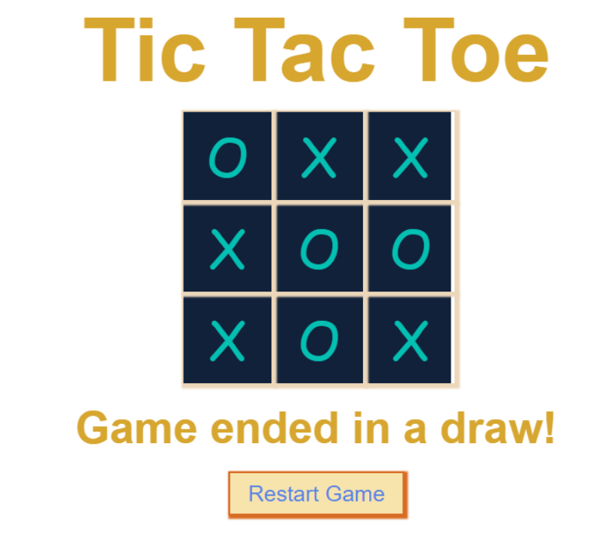

**2. Timetable using Table tag in HTML**

**<!DOCTYPE html>**

**<html>**

**<head>**

**<title>TimeTable</title>**

**</head>**

**<body>**

**<!--TimeTable using HTML codes by Bob TekZone-->**

**<table border="3px" cellspacing="5px" cellpadding="10px">**

**<caption>Time-Table</caption>**

**<tr>**

**<th colspan="6">**

**<pre>**

**Sec:A**

**</pre></th>**

**<!--<pre> tag used for writing the content same as in codes without any changes-->**

**</tr>**

**<tr>**

**<th>Day/Time</th>**

**<th>1st Period 09:00-10:00am</th>**

**<th>2nd Period 10:00-11:00am</th>**

**<th>Break 11:00-11:30am</th>**

**<!--<td></td> & <th></th> both used for column, <th></th> is a table header -->**

**<th>3rd Period 11:30am-12:30pm</th>**

**<th>4th Period 12:30-01:30pm</th>**

**</tr>**

**<tr>**

**<td>Monday</td>**

**<td>WD</td>**

**<td>Automata</td>**

**<td rowspan="6"><center>B<br>R<br>E<br>A<br>K<br></center></td>**

**<td>Python</td>**

**<td>OS</td>**

**</tr>**

**<tr>**

**<td>Tuesday</td>**

**<td>Math</td>**

**<td>WD</td>**

**<td>Python</td>**

**<td>Automata</td>**

**</tr>**

**<tr>**

**<td>Wednesday</td>**

**<td>Quants</td>**

**<td>HV</td>**

**<td>English</td>**

**<td>WD</td>**

**</tr>**

**<tr>**

**<td>Thursday</td>**

**<td>Automata</td>**

**<td>Math</td>**

**<td>WD</td>**

**<td>OS</td>**

**</tr>**

**<tr>**

**<td>Friday</td>**

**<td>OS</td>**

**<td>Python</td>**

**<td>Automata</td>**

**<td>WD</td>**

**</tr>**

**<tr>**

**<td>Saturday</td>**

**<td>PSD</td>**

**<td>OS</td>**

**<td>Reasoning</td>**

**<td>HV</td>**

**</tr>**

**</table>**

**</body>**

**<html>**

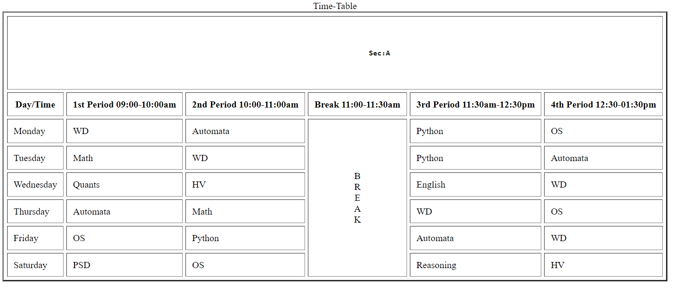

**3.Registration Form**

**<!DOCTYPE html>**

**<html>**

**<head>**

**<title>Login and Registration Form in HTML</title>**

**</head>**

**<body>**

**<div class="wrapper">**

**<div class="title-text">**

**<div class="title login">**

**Login Form**

**</div>**

**<div class="title Register">**

**Registration Form**

**</div>**

**</div>**

**<div class="form-container">**

**<div class="slide-controls">**

**<input type="radio" name="slide" id="login" checked>**

**<input type="radio" name="slide" id="register">**

**<label for="login" class="slide login">Login</label>**

**<label for="Register" class="slide signup">Register </label>**

**<div class="slider-tab"></div>**

**</div>**

**<div class="form-inner">**

**<form action="#" class="login">**

**<div class="field">**

**<input type="text" placeholder="Email Address" required>**

**</div>**

**<div class="field">**

**<input type="password" placeholder="Password" required>**

**</div>**

**<div class="pass-link">**

**<a href="#">Forgot password?</a>**

**</div>**

**<div class="field btn">**

**<div class="btn-layer"></div>**

**<input type="submit" value="Login">**

**</div>**

**<div class="Register-link">**

**Not registered? <a href="">Register now</a>**

**</div>**

**</form>**

**<form action="#" class="Register">**

**<div class="field">**

**<input type="text" placeholder="Email Address" required>**

**</div>**

**<div class="field">**

**<input type="password" placeholder="Password" required>**

**</div>**

**<div class="field">**

**<input type="password" placeholder="Confirm password" required>**

**</div>**

**<div class="field btn">**

**<div class="btn-layer"></div>**

**<input type="submit" value="Register">**

**</div>**

**</form>**

**</div>**

**</div>**

**</div>**

**<script>**

**const loginText = document.querySelector(".title-text .login");**

**const loginForm = document.querySelector("form.login");**

**const loginBtn = document.querySelector("label.login");**

**const signupBtn = document.querySelector("label.signup");**

**const signupLink = document.querySelector("form .signup-link a");**

**signupBtn.onclick = (()=>{**

**loginForm.style.marginLeft = "-50%";**

**loginText.style.marginLeft = "-50%";**

**});**

**loginBtn.onclick = (()=>{**

**loginForm.style.marginLeft = "0%";**

**loginText.style.marginLeft = "0%";**

**});**

**signupLink.onclick = (()=>{**

**signupBtn.click();**

**return false;**

**});**

**</script>**

**<style>**

**\*{**

**margin: 0;**

**padding: 0;**

**box-sizing: border-box;**

**font-family: 'Poppins', sans-serif;**

**}**

**html,body{**

**display: grid;**

**height: 100%;**

**width: 100%;**

**place-items: center;**

**background: #87CEEB;**

**}**

**::selection{**

**background: #fa4299;**

**color: #fff;**

**}**

**.wrapper{**

**overflow: hidden;**

**max-width: 390px;**

**background: #fff;**

**padding: 30px;**

**border-radius: 5px;**

**box-shadow: 0px 15px 20px rgba(0,0,0,0.1);**

**}**

**.wrapper .title-text{**

**display: flex;**

**width: 200%;**

**}**

**.wrapper .title{**

**width: 50%;**

**font-size: 35px;**

**font-weight: 600;**

**text-align: center;**

**transition: all 0.6s cubic-bezier(0.68,-0.55,0.265,1.55);**

**}**

**.wrapper .slide-controls{**

**position: relative;**

**display: flex;**

**height: 50px;**

**width: 100%;**

**overflow: hidden;**

**margin: 30px 0 10px 0;**

**justify-content: space-between;**

**border: 1px solid lightgrey;**

**border-radius: 5px;**

**}**

**.slide-controls .slide{**

**height: 100%;**

**width: 100%;**

**color: #fff;**

**font-size: 18px;**

**font-weight: 500;**

**text-align: center;**

**line-height: 48px;**

**cursor: pointer;**

**z-index: 1;**

**transition: all 0.6s ease;**

**}**

**.slide-controls label.signup{**

**color: #000;**

**}**

**.slide-controls .slider-tab{**

**position: absolute;**

**height: 100%;**

**width: 50%;**

**left: 0;**

**z-index: 0;**

**border-radius: 5px;**

**background: -webkit-linear-gradient(left, #a445b2, #fa4299);**

**transition: all 0.6s cubic-bezier(0.68,-0.55,0.265,1.55);**

**}**

**input[type="radio"]{**

**display: none;**

**}**

**#signup:checked ~ .slider-tab{**

**left: 50%;**

**}**

**#signup:checked ~ label.signup{**

**color: #fff;**

**cursor: default;**

**user-select: none;**

**}**

**#signup:checked ~ label.login{**

**color: #000;**

**}**

**#login:checked ~ label.signup{**

**color: #000;**

**}**

**#login:checked ~ label.login{**

**cursor: default;**

**user-select: none;**

**}**

**.wrapper .form-container{**

**width: 100%;**

**overflow: hidden;**

**}**

**.form-container .form-inner{**

**display: flex;**

**width: 200%;**

**}**

**.form-container .form-inner form{**

**width: 50%;**

**transition: all 0.6s cubic-bezier(0.68,-0.55,0.265,1.55);**

**}**

**.form-inner form .field{**

**height: 50px;**

**width: 100%;**

**margin-top: 20px;**

**}**

**.form-inner form .field input{**

**height: 100%;**

**width: 100%;**

**outline: none;**

**padding-left: 15px;**

**border-radius: 5px;**

**border: 1px solid lightgrey;**

**border-bottom-width: 2px;**

**font-size: 17px;**

**transition: all 0.3s ease;**

**}**

**.form-inner form .field input:focus{**

**border-color: #fc83bb;**

**}**

**.form-inner form .field input::placeholder{**

**color: #999;**

**transition: all 0.3s ease;**

**}**

**form .field input:focus::placeholder{**

**color: #b3b3b3;**

**}**

**.form-inner form .pass-link{**

**margin-top: 5px;**

**}**

**.form-inner form .signup-link{**

**text-align: center;**

**margin-top: 30px;**

**}**

**.form-inner form .pass-link a,**

**.form-inner form .signup-link a{**

**color: #fa4299;**

**text-decoration: none;**

**}**

**.form-inner form .pass-link a:hover,**

**.form-inner form .signup-link a:hover{**

**text-decoration: underline;**

**}**

**form .btn{**

**height: 50px;**

**width: 100%;**

**border-radius: 5px;**

**position: relative;**

**overflow: hidden;**

**}**

**form .btn .btn-layer{**

**height: 100%;**

**width: 300%;**

**position: absolute;**

**left: -100%;**

**background: -webkit-linear-gradient(right, #a445b2, #fa4299, #a445b2, #fa4299);**

**border-radius: 5px;**

**transition: all 0.4s ease;;**

**}**

**form .btn:hover .btn-layer{**

**left: 0;**

**}**

**form .btn input[type="submit"]{**

**height: 100%;**

**width: 100%;**

**z-index: 1;**

**position: relative;**

**background: none;**

**border: none;**

**color: #fff;**

**padding-left: 0;**

**border-radius: 5px;**

**font-size: 20px;**

**font-weight: 500;**

**cursor: pointer;**

**}**

**</style>**

**</body>**

**</html>**

